Daniel Meyer

CSE 520

Tong Yu

**Homework 3 Report**

**Part 1 (success):**

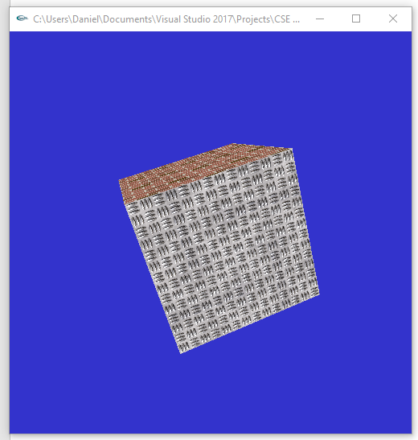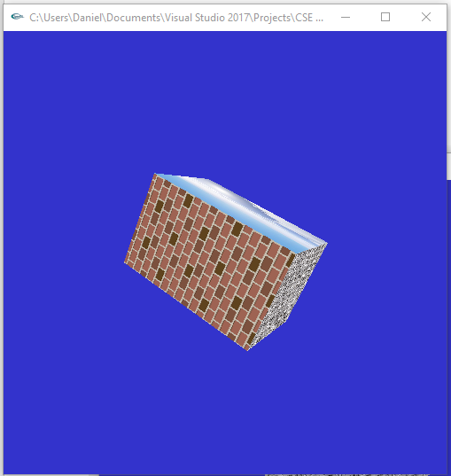

#include <stdlib.h>

#include <stdio.h>

#include <string.h>

#include <time.h>

#define GLEW_STATIC 1

#include <GL/glut.h>

#include <SOIL/SOIL.h>

int texImageWidth;

int texImageHeight;

int window;

static GLuint texName[6]; //texture names

int anglex = 0, angley = 0, anglez = 0; //rotation angles

float scale = 1;

int timeCounter = 0; // time counter

int time_interval = 10; // how much time has to be before action is done

//images for texture maps for 6 faces of cube

char maps[][20] = { "floor.png", "player.png", "right.png", "stone.png",

"wall.png", "cubemap_dn.png" };

//load texture image

GLubyte *makeTexImage(char *loadfile)

{

int i, j, c, width, height;

GLubyte *texImage;

/*

Only works for .png or .tif images. NULL is returned if errors occurred.

loadImageRGA() is from imageio library downloaded from Internet.

*/

//texImage = loadImageRGBA((char *)loadfile, &width, &height);

texImage = SOIL_load_image(loadfile, &width, &height, 0, SOIL_LOAD_RGBA);

texImageWidth = width;

texImageHeight = height;

return texImage;

}

void init(void)

{

glClearColor(0.2, 0.2, 0.8, 0.0);

glShadeModel(GL_FLAT);

glEnable(GL_DEPTH_TEST);

glPixelStorei(GL_UNPACK_ALIGNMENT, 1);

//texName is global

glGenTextures(6, texName);

for (int i = 0; i < 6; ++i)

{

GLubyte *texImage = makeTexImage(maps[i]);

if (!texImage) {

printf("\nError reading %s \n", maps[i]);

continue;

}

glBindTexture(GL_TEXTURE_2D, texName[i]); //now we work on texName

glTexParameteri(GL_TEXTURE_2D, GL_TEXTURE_WRAP_S, GL_REPEAT);

glTexParameteri(GL_TEXTURE_2D, GL_TEXTURE_WRAP_T, GL_REPEAT);

glTexParameteri(GL_TEXTURE_2D, GL_TEXTURE_MAG_FILTER, GL_NEAREST);

glTexParameteri(GL_TEXTURE_2D, GL_TEXTURE_MIN_FILTER, GL_NEAREST);

glTexImage2D(GL_TEXTURE_2D, 0, GL_RGBA, texImageWidth,

texImageHeight, 0, GL_RGBA, GL_UNSIGNED_BYTE, texImage);

delete texImage; //free memory holding texture image

}

}

void display(void)

{

glClear(GL_COLOR_BUFFER_BIT | GL_DEPTH_BUFFER_BIT);

glEnable(GL_TEXTURE_2D);

glTexEnvf(GL_TEXTURE_ENV, GL_TEXTURE_ENV_MODE, GL_DECAL);

float x0 = -1.0, y0 = -1, x1 = 1, y1 = 1, z0 = 1;

float face[6][4][3] = { {{x0, y0, z0}, {x1, y0, z0}, {x1, y1, z0}, {x0, y1, z0}}, //front

{{x0, y1, -z0}, {x1, y1, -z0}, {x1, y0, -z0}, {x0, y0, -z0}}, //back

{{x1, y0, z0}, {x1, y0, -z0}, {x1, y1, -z0}, {x1, y1, z0}}, //right

{{x0, y0, z0}, {x0, y1, z0}, {x0, y1, -z0}, {x0, y0, -z0}}, //left

{{x0, y1, z0}, {x1, y1, z0}, {x1, y1, -z0}, {x0, y1, -z0}}, //top

{{x0, y0, z0}, {x0, y0, -z0}, {x1, y0, -z0}, {x1, y0, z0}} //bottom

};

glEnable(GL_CULL_FACE);

glCullFace(GL_BACK);

glPushMatrix();

glRotatef(anglex, 1.0, 0.0, 0.0); //rotate the cube along x-axis

glRotatef(angley, 0.0, 1.0, 0.0); //rotate along y-axis

glRotatef(anglez, 0.0, 0.0, 1.0); //rotate along z-axis

glScalef(scale, scale, 1);

for (int i = 0; i < 6; ++i) { //draw cube with texture images

glBindTexture(GL_TEXTURE_2D, texName[i]);

glBegin(GL_QUADS);

glTexCoord2f(0.0, 0.0); glVertex3fv(face[i][0]);

glTexCoord2f(1.0, 0.0); glVertex3fv(face[i][1]);

glTexCoord2f(1.0, 1.0); glVertex3fv(face[i][2]);

glTexCoord2f(0.0, 1.0); glVertex3fv(face[i][3]);

glEnd();

}

glPopMatrix();

glFlush();

glDisable(GL_TEXTURE_2D);

}

static void Idle(void)

{

float time = glutGet(GLUT_ELAPSED_TIME);

while (time > 2000) time -= 2000;

anglex += (time / 1000) * 1;

angley += (time / 1000) * 1;

anglez += (time / 1000) * 1;

if (anglex > 360)

anglex = 0;

if (angley > 360)

angley = 0;

if (anglez > 360)

anglez = 0;

if (scale > 1.5)

{

scale = 0.5;

}

scale += (time / 1000) * 0.0001;

glutPostRedisplay();

}

void keyboard(unsigned char key, int x, int y)

{

switch (key) {

case 'x':

anglex = (anglex + 3) % 360;

break;

case 'X':

anglex = (anglex - 3) % 360;

break;

case 'y':

angley = (angley + 3) % 360;

break;

case 'Y':

angley = (angley - 3) % 360;

break;

case 'z':

anglez = (anglez + 3) % 360;

break;

case 'Z':

anglez = (anglez - 3) % 360;

break;

case 27: /* escape */

glutDestroyWindow(window);

exit(0);

}

glutPostRedisplay();

}

void reshape(int w, int h)

{

glViewport(0, 0, (GLsizei)w, (GLsizei)h);

glMatrixMode(GL_PROJECTION);

glLoadIdentity();

gluPerspective(60.0, (GLfloat)w / (GLfloat)h, 1.0, 30.0);

glMatrixMode(GL_MODELVIEW);

glLoadIdentity();

gluLookAt(0, 0, 5, 0, 0, 0, 0, 1, 0);

}

int main(int argc, char** argv)

{

glutInit(&argc, argv);

glutInitDisplayMode(GLUT_SINGLE | GLUT_RGB | GLUT_DEPTH);

glutInitWindowSize(500, 500);

glutInitWindowPosition(100, 100);

window = glutCreateWindow(argv[0]);

init();

glutDisplayFunc(display);

glutReshapeFunc(reshape);

glutKeyboardFunc(keyboard);

glutIdleFunc(Idle);

glutMainLoop();

return 0;

}

**Part 2 (success):**

**Body**

For the body I used the starting cube and scaled it byt 2x in the z direction to make it a rectangle and then transformed it to account for the legs and arms.

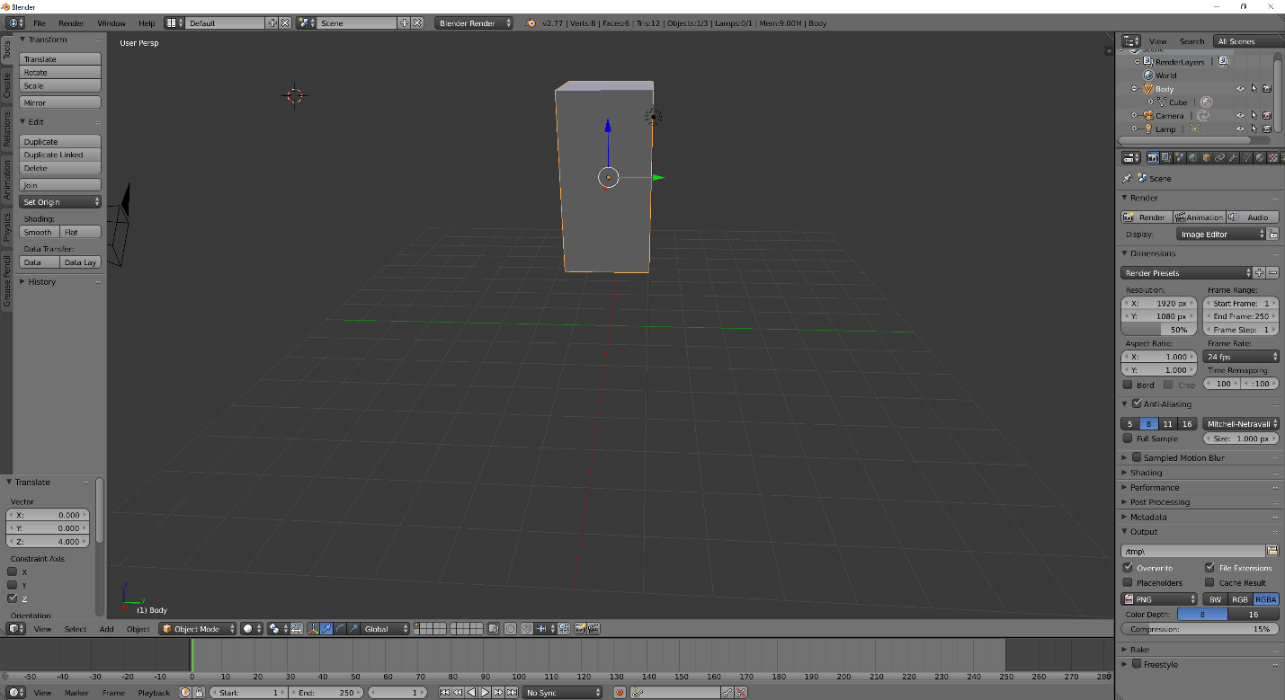

**Head**

Next, I added a UV sphere to use for the head and adjusted the transform so it would appear on top of the body.

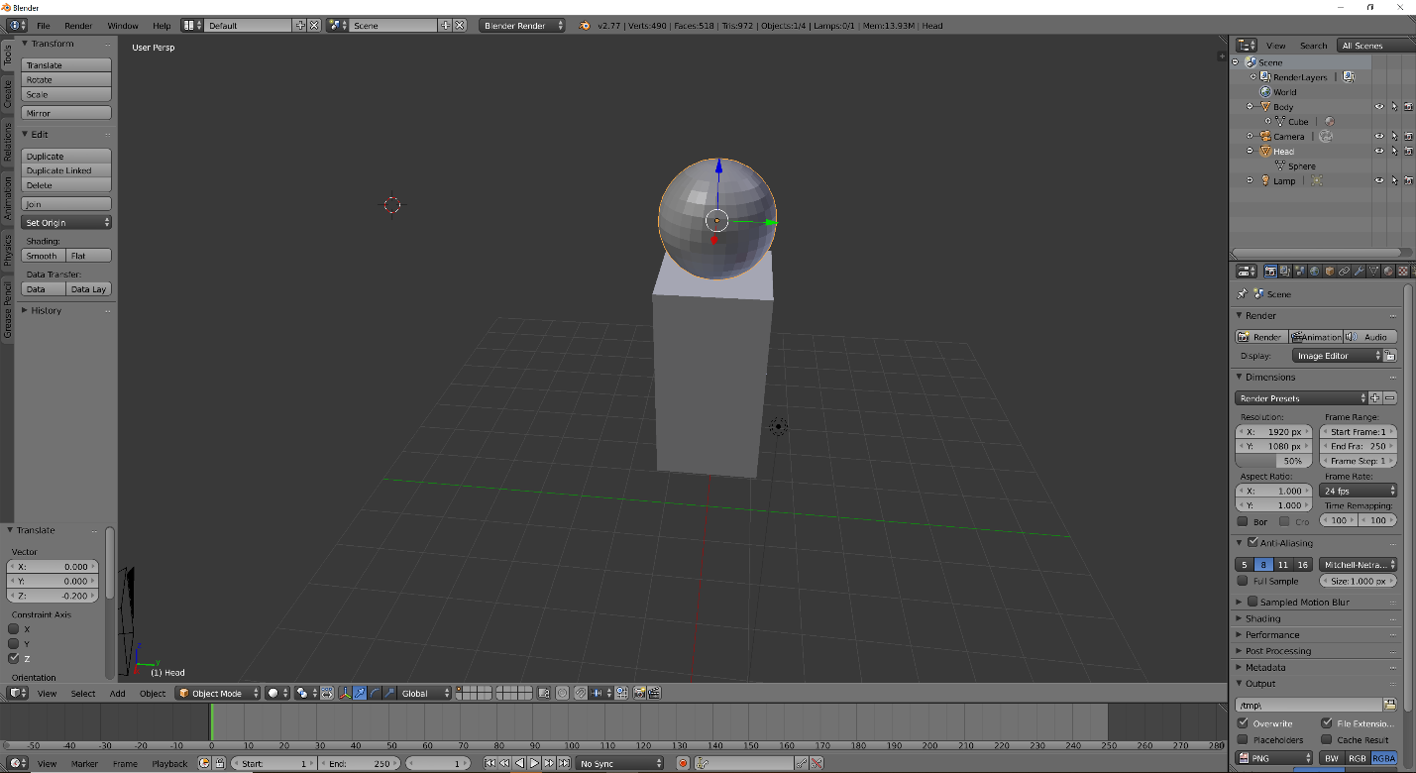

**Arms**

For the arms I created another cube then scaled it to be smaller than the body and be a rectangle. Next, I rotated it and then transformed it to attach to the body. I repeated these steps for the lower arm and finally made another UV sphere to use as the hand and scaled it down. Then I transformed it to the end of the lower arm. For the left arm I simply copied the right arm steps but rotated and translated in the opposite direction.

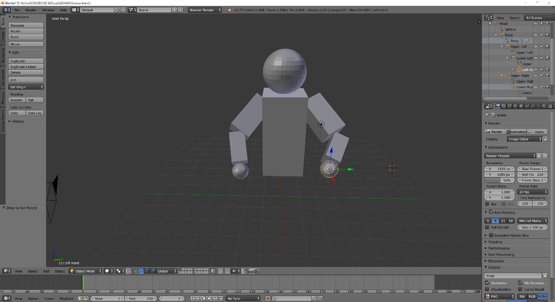

**Legs**

For the legs I performed the same steps for the arms, but instead I used different rotations and translations to have the cubes and spheres appear under the body as legs. I also organized the hierarchy of all the limbs to appear from head down (i.e. head parent of body, body parent of limbs).

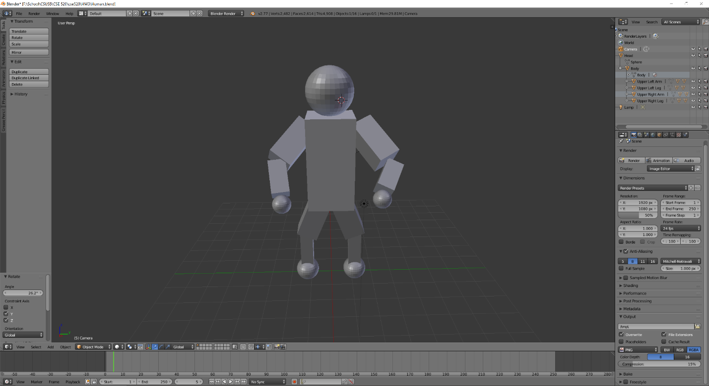

**Summary:**

Overall this assignment was a lot of fun. The first part creating the cube was a lot of fun and I did have some issues getting the rotations to work properly, but incidentally created I cool shuffling effect that I decided to keep. The portion of Blender was different, and I enjoyed being able to work in that environment for a bit. I do want to investigate importing the human I made in Blender into my final project in some way. Overall, my program compiled and ran successfully as well as I created a human in Blender. I believe I earned the full 40 points for the assignment.